

**SOFTWARE REQUIREMENT SPECIFICATION (SRS) SIGN-OFF**

**Authorization Memorandum**

This form is to sign-off completion of the Requirement Phase for **CAMPUS MANAGEMENT SOFTWARE AT WORLD SKILL CENTER (WSC).**

World Skill Centre (WSC) acknowledges receipt of the deliverables as part of the Requirement Phase through the submission of this document.

|  |  |
| --- | --- |
| **MODULE NAME** | **Finance Budget** |

| **VERSION HISTORY** | | | |
| --- | --- | --- | --- |
| **Version** | **Author** | **Date** | **Changes** |
|  |  |  |  |
|  |  |  |  |

**WSC AUTHORITY NAME AND**  **SIGNATURE**

**SOUL AUTHORITY NAME AND**  **SIGNATURE**

Pages 1 of 12





**Software Requirement Specification (SRS)**

Of

Finance Budget

For Implementation of

**Campus Management Software**

at

**World Skill Center (WSC)**

**Sustainable Outreach And Universal**

**Leadership (SOUL) Limited**

**Table of Content**

A. Abstract 3

B. Introduction 3

C. Definition, Acronyms and Abbreviations 3

D. Overview of the Document 3

E. Scope of Accounting Module 4

F. List of Screens and Their Descriptions 4

G. Financial Budget 5

1. Finance Processes 5

1.1 Budget 5

1.2 Monthly Distribution 8

1.3 Budget Variance Report 9

# Abstract

Software Requirements Gathering is one of the first phases of system development. This phase results in the Software Requirements Specification (SRS) document, which must contain a complete, concise, high-quality description of the system being considered.

# Introduction

The World Skill Center (WSC) is a premier advanced skill training institute established by the Government of Odisha, Skill Development and Technical Education Department, through the Odisha Skill Development Authority (OSDA). The WSC will impart advanced skill training in eight trades from engineering and service sectors. WSC caters primarily to induct the best talent from ITIs and Polytechnics and train them to become globally employable in emerging areas such as "Industry 4.0". WSC is housed in a state-of-the-art, 18-storey, air-conditioned building with nearly half a million square feet of space in the heart of capital city of Bhubaneswar.

With the implementation of campus management software for WSC the goal is to streamline the operations and functions of the campus by integrating various processes, such as admissions, course registration, academic progress tracking, and financial management, HRMS, Procurement and Inventory management, etc into a unified system. The implementation also aims at providing a user-friendly interface for all stakeholders, making it easier for them to access the necessary information and complete their tasks with ease. The modules to be covered during the implementation of the software includes:

|  |  |
| --- | --- |
| Students Management Modules | Infrastructure Management |
| Academic System | Finance and Accounting System |
| Procurement & Inventory Management | Training and Placement |
| Human Resources Management System | Application Integration |

# Definition, Acronyms and Abbreviations

The following table explains the terms and abbreviations used in the document:

|  |  |
| --- | --- |
| **Abbreviation** | **Description** |
| SRS | Software Requirements Specification |
| SLCM | Student Life Cycle Management |
| R | Rename - When a field is Renamed |
| N | New - When a New field is Added |
| D | Delete - When an Existing field is Deleted |
| NA | Not Applicable |

# Overview of the Document

This requirement document provides a detailed overview of the functional requirements of a project. It serves as a communication tool between stakeholders, including developers, project managers, and end-users. The purpose of this requirement document is to define and document the project's objectives, scope, and expectations, and to ensure that all stakeholders have a clear understanding of what the project entails.

This document covers all the functional requirements of the **Examination module** of ERP Product. The ERP Examination module helps in organizing the entire education set-up, such as Student Database, Fee Structure, Trainer Information Assessment and Result Declaration and Cumulative Marksheet, Certificate Generation, etc.

# Scope of Accounting Module

* Receipt and Payment Entries
* Direct Transfer of Caution Money to Student’s Accounts
* Demand Register
* Caution Money Register
* Bank Reconciliation Statement
* Generation of Cash Book (PL)
* Grants-in-aid Register
* Paid Voucher Register
* Advances Register
* Auditing and Tracking Pendency of Audit paras etc.

Functionalities are covered in this SRS document:

* **Accounting Budget**

# **List of Screens and Their Descriptions**

|  |  |  |
| --- | --- | --- |
| Prerequisite screens Required for Entrance Exam & Counselling | | |
| **ID** | **Screen Name** | **Description** |
|  | Budget | Budgeting is a financial plan that helps controlling Company expenses. Budgets are also great for planning purposes. When you are making plans for the next Financial Year, you would typically target a revenue based on which you would set your expenses. Setting a budget will ensure that your expenses do not get out of hand at any point. |
|  | Monthly Distribution | You can also define a Monthly Distribution record to distribute the budget between months. System will calculate the budget yearly or in equal proportion for every month. |
|  | Budget Variance Report | At any point in time, you can check the Budget Variance Report to analyze the actual expense incurred vs budget allocated against a cost center or a project.. |

# Financial Budget

## Finance Processes

Following are the screens used to achieve the functionalities of Budget.

## 1.1 Budget

**General Description**

The following table describes overall information about this screen:

|  |  |
| --- | --- |
| **Description** | 1. Budgeting is a financial plan that helps controlling Company expenses. 2. Budgets can be managed against a Cost Center 3. Accounting Dimensions to tag transactions with different fields 4. Budgets are also great for planning purposes. When you are making plans for the next Financial Year, you would typically target a revenue based on which you would set your expenses. Setting a budget will ensure that your expenses do not get out of hand at any point. |
| **Navigation** | Home > Accounting > Cost Center and Budgeting > Budget |
| **Pre-requisites** | The system should have records in the following screen   1. Company 2. Cost Center 3. Fiscal Year 4. Monthly Distribution |
| **Existing Screen Name** | Budget |
| **New Screen Name** | No change |

**Screenshot**

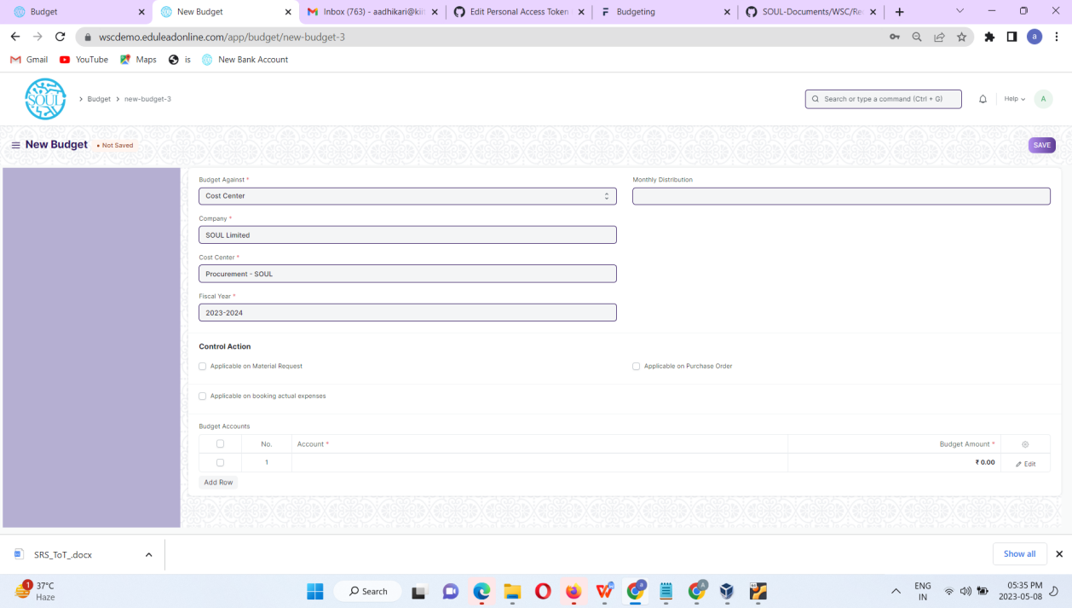

Figure 2 : Budget Screen

**Field List**

The following table describes the UI fields present in this screen :

|  |  |  |  |  |  |  |  |
| --- | --- | --- | --- | --- | --- | --- | --- |
| **ID** | **Field Name** | **Field Type** | **Mandatory** | **Validation/ Action** | **Remarks** | | **R/N/D** |
| 1 | Budget Against | DropDown | Yes | Option: 1. Cost Center 2. Project |  | |  |
| 2 | Company | Link Field | Yes | Link Field to Company screen |  | |  |
| 3 | Cost Center | Link Field |  | Link Field to Cost Center |  | |  |
| 4 | Series | Data Field |  |  |  | |  |
| 5 | Project | Link Field |  | Link Field to Project |  | |  |
| 6 | Fiscal Year | Link Field | Yes | Link Field to Fiscal Year |  | |  |
| 7 | Monthly Distribution | Link Field |  | Link Field to Monthly Distribution |  | |  |
| 8 | Applicable on Material Request | Check Box |  | On Check Box of the this 2 field will be populated  1. Action if Annual Budget Exceeded on MR 2. Action if Accumulated Monthly Budget Exceeded on MR |  | |  |
| 9 | Action if Annual Budget Exceeded on MR | DropDown |  | Option:  1. Stop 2. Warn 3. Ignore |  | |  |
| 10 | Action if Accumulated Monthly Budget Exceeded on MR | DropDown |  | Option:  1. Stop 2. Warn 3. Ignore |  | |  |
| 11 | Applicable on Purchase Order | Check Box |  | On Check Box of the this 2 field will be populated  1. Action if Annual Budget Exceeded on PO 2. Action if Accumulated Monthly Budget Exceeded on PO | |  |  |
| 12 | Action if Annual Budget Exceeded on PO | DropDown |  | Option:  1. Stop 2. Warn 3. Ignore | |  |  |
| 13 | Action if Accumulated Monthly Budget Exceeded on PO | DropDown |  | Option:  1. Stop 2. Warn 3. Ignore |  | |  |
| 14 | Applicable on booking actual expenses | Check Box |  | On Check Box of the this 2 field will be populated  1. Action if Annual Budget Exceeded on Actual 2. Action if Accumulated Monthly Budget Exceeded on Actual |  | |  |
| 15 | Action if Annual Budget Exceeded on Actual | DropDown |  | Option:  1. Stop 2. Warn 3. Ignore |  | |  |
| 16 | Action if Accumulated Monthly Budget Exceeded on Actual | DropDown |  | Option:  1. Stop 2. Warn 3. Ignore |  | |  |
| 17 | Budget Accounts | Table | YES |  |  | |  |
| **ID** | **Field Name** | **Field Type** | **Mandatory** | **Validation/ Action** | **Remarks** | | **R/N/D** |
| 1 | Account | Link Field | Yes | Link Field to Account |  | |  |
| 2 | Budget Amount | Currency | Yes |  |  | |  |

Note:-

Control Actions (Alerts)

Control actions can be triggered when:

* A Material Request is being submitted
* A Purchase Order is being submitted

When an actual expense is being posted (through a journal entry or a purchase invoice).

You can set a control action in the Budget based on Material Requests, Purchase Orders, or on actual expenses. Further, you can set a control action for annual or monthly budgets.

There are three types of control actions.

* ****Stop****: This will not allow users to submit the transaction.
* ****Warn****: This will show a warning message but lets the user submit the transaction.
* ****Ignore****: This will neither prevent the user from submitting transactions nor show an error message.

Similar warning will be triggered for any type of transactions set in the budget for the particular Account heads.

**User: Roles & Permission**

The following table describes the users and their roles and permissions for the screens :

|  |  |  |  |  |  |  |  |  |
| --- | --- | --- | --- | --- | --- | --- | --- | --- |
| **ID** | **Role** | **Read** | **Write** | **Create** | **Delete** | **Submit** | **Cancel** | **Amend** |
| 1 | Accountant Admin | Yes | Yes | Yes | Yes | Yes | Yes | Yes |
| 2 | Account Manager | Yes | Yes | Yes | Yes | Yes | No | No |
| 3 | Account User | Yes | No | No | No | No | No | No |

## 1.2 Monthly Distribution

**General Description**

The following table describes overall information about this screen:

|  |  |
| --- | --- |
| **Description** | 1. You can also define a Monthly Distribution record to distribute the budget between months. 2. System will calculate the budget yearly or in equal proportion for every month. |
| **Navigation** | Home > Accounting > Cost Center and Budgeting > Monthly Distribution |
| **Pre-requisites** | 1.Fiscal Year |
| **Existing Screen Name** | Monthly Distribution |
| **New Screen Name** | No |

**Screenshot**

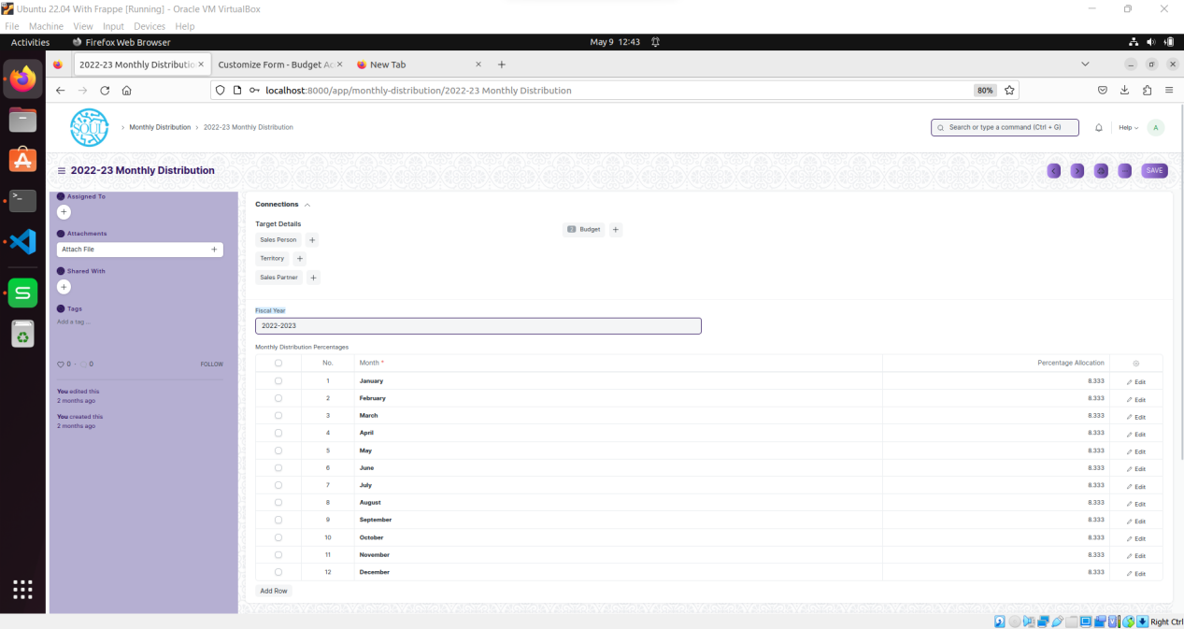

Figure 3 : Monthly Distribution

**Field List**

The following table describes the UI fields present in this screen :

|  |  |  |  |  |  |  |
| --- | --- | --- | --- | --- | --- | --- |
| **ID** | **Field Name** | **Field Type** | **Mandatory** | **Validation / Action** | **Remarks** | **R/N/D** |
| 1 | Distribution Name | Data | Yes |  |  |  |
| 2 | Fiscal Year | Link |  | Field is linked to Fiscal Year |  |  |
| 3 | Monthly Distribution Percentages | Table |  |  |  |  |

|  |  |  |  |  |  |  |
| --- | --- | --- | --- | --- | --- | --- |
| **ID** | **Field Name** | **Field Type** | **Mandatory** | **Validation / Action** | **Remarks** | **R/N/D** |
| 1 | Month | Data Field | Yes | Only month of the year will be displayed |  |  |
| 2 | Percentage Allocation | Float |  |  |  |  |

**User: Roles & Permission**

The following table describes the users and their roles and permissions for the screens :

|  |  |  |  |  |  |  |  |  |
| --- | --- | --- | --- | --- | --- | --- | --- | --- |
| **ID** | **Role** | **Read** | **Write** | **Create** | **Delete** | **Submit** | **Cancel** | **Amend** |
| 1 | Accountant Admin | Yes | Yes | Yes | Yes | Yes | Yes | Yes |
| 2 | Account Manager | Yes | Yes | Yes | Yes | Yes | No | No |
| 3 | Account User | Yes | No | No | No | No | No | No |

## 1.3 Budget Variance Report

**General Description**

The following table describes overall information about this screen:

|  |  |
| --- | --- |
| **Description** | At any point in time, you can check the Budget Variance Report to analyze the actual expense incurred vs budget allocated against a cost center or a project.. |
| **Navigation** | Home > Accounting > Cost Center and Budgeting > Budget Variance Report |
| **Pre-requisites** | 1. Fiscal Year 2. Period 3. Cost Center 4. Company 5. Accounting Dimensions |
| **Existing Screen Name** | Budget Variance Report |
| **New Screen Name** | NA |

**Screenshot**

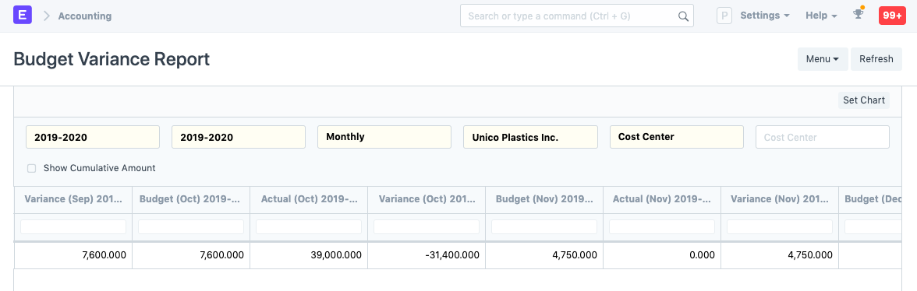

Figure 4 : Budget Variance Report

**Field List**

The following table describes the UI fields present in this screen :

|  |  |  |  |  |  |  |
| --- | --- | --- | --- | --- | --- | --- |
| **ID** | **Field Name** | **Field Type** | **Mandatory** | **Validation / Action** | **Remarks** | **R/N/D** |
| 1 | From Fiscal Year | Link Field | Yes | Linked to Fiscal Year |  |  |
| 2 | To Fiscal Year | Link Field | Yes | Fiscal Year |  |  |
| 3 | Period | Dropdown | Yes | Option:   1. Monthly 2. Yearly 3. Half Yearly 4. Quarterly |  |  |
| 4 | Company | Link Field | Yes | Linked to Company |  |  |
| 5 | Budget Against | Dropdown | Yes | Option:   1. Cost Center 2. Budget |  |  |
| 6 | Dimension Filter | Multi-select | Yes | Based of selection of Budget Against Cost Center or Project can be Selected |  |  |

**Report Fields:-**

|  |  |  |  |  |  |  |
| --- | --- | --- | --- | --- | --- | --- |
| **ID** | **Field Name** | **Field Type** | **Mandatory** | **Validation / Action** | **Remarks** | **R/N/D** |
| 1 | Variance | Data |  | Based on the Period Selection |  |  |
| 2 | Budget | Data |  | Based on the Period Selection |  |  |

**User: Roles & Permission**

The following table describes the users and their roles and permissions for the screens :

|  |  |  |  |  |  |  |  |  |
| --- | --- | --- | --- | --- | --- | --- | --- | --- |
| **ID** | **Role** | **Read** | **Write** | **Create** | **Delete** | **Submit** | **Cancel** | **Amend** |
| 1 | Accountant Admin | Yes | NA | NA | NA | NA | NA | NA |
| 2 | Account Manager | Yes | NA | NA | NA | NA | NA | NA |
| 3 | Account User | Yes | NA | No | NA | NA | NA | NA |